The Fund Activity Report resembles a bank statement by presenting tabulated details on the fund's previous balance and current balance, and a history of financial activity. This report displays information for each fund based on the current data in the Payment History file. The Payment History file records all appropriations, expenditures, encumbrances, and disencumbrances that were posted since the file was last cleared. Additionally, this report lists all funds that are out of balance.

Note: Because the file holds a maximum of 10,000 transactions, you must clear it before this number is reached. It might be best to run this report at least 4 times a year.

Before clearing the report, it might be best to change the Number of funds to load per page. Go to Admin>> Settings>>Funds. Change the default from 25 to 100.
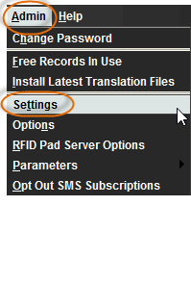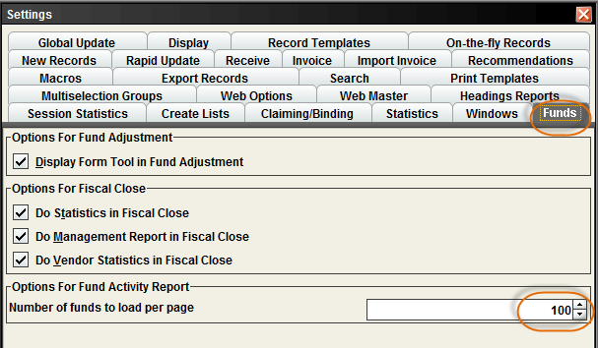

Click on Funds from the FUNCTION menu.
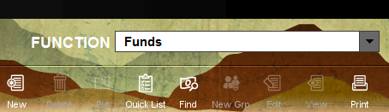

This will bring up all your library’s Funds. You will see Current Funds, as well as any Hierarchies and Old Funds, if available. You may also see numbers in the Appropriation, Expenditure, Encumbrance, Free Balance and Cash Balance columns.
.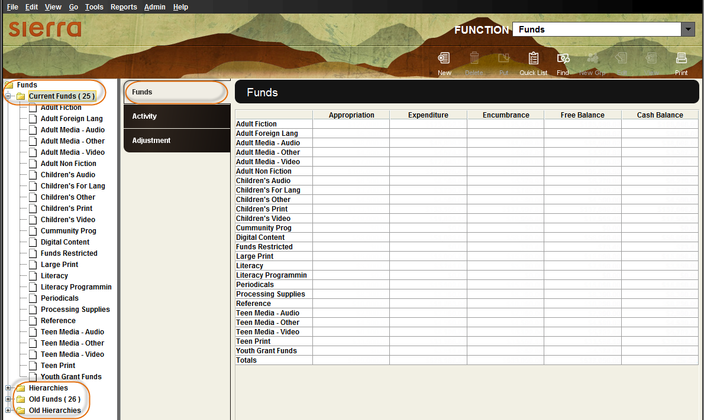

Click on Activity.
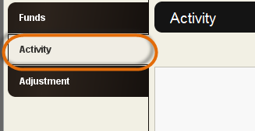

This will bring up the Activity page. You want to use the Report Header. Type in the two to three letter code for your library. Click Show all, if you want to include data on all funds in the Current Funds subfolder, even those that have had no transactions. Click Start.
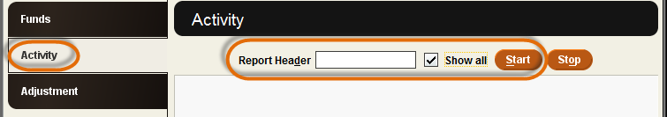

This will bring the Activity Summary that lists the last encumbrance and last voucher information. Click OK.
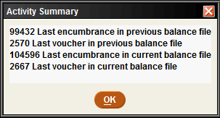
For each fund, the table displays financial figures broken into columns for Appropriation, Expenditure, and Encumbrance, according to categories of PREVIOUS BALANCE, CURRENT ACTIVITY, and CURRENT BALANCE. A summary of the number of payments (or encumbrances) made, year-to-date averages, totals, and any out of balance errors appears for each fund. If your library uses subfunds, the Fund Activity Report also includes subfund expenditures and the percentage of the total fund expenditure for each subfund.

This is an example of a portion of the Fund Activity Report:
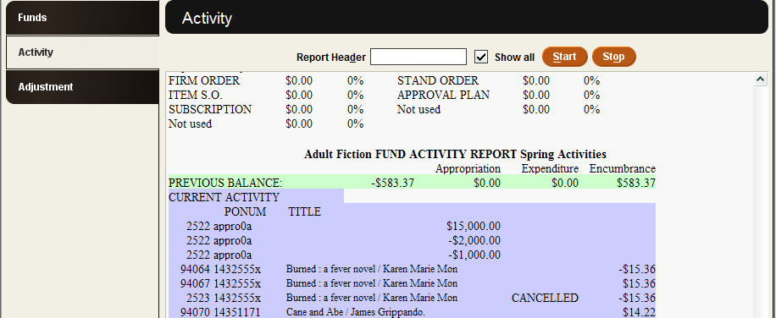
At the bottom of the screen should be the messages, “Fund Activity Report in progress”, and “0 Out of balance.”
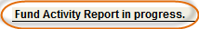

When the reports are finished, you should see a message at the bottom left of the screen, “Fund Activity Report complete.”
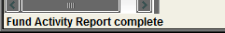

Note: If you have not already printed to your standard printer, you will have to reset your printer. Go to File>>Select Printer>>Standard Printer.
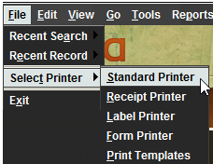

This will bring up the Select Standard Printer box. Click on E-mail Printer. Click OK. Enter an email address. Click OK.
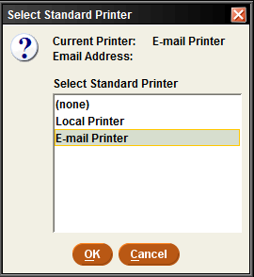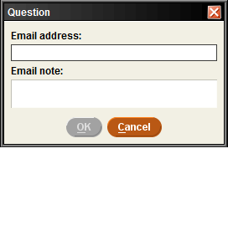

Choose Print.
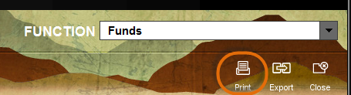

Click on E-mail Printer. Click OK. Enter an email address. Click OK.

In the Printing Complete dialog, confirm if the Printout is OK (select the check box). If no funds are out of balance and you want to clear the Payment History file, select Clear payment history from the dialog. If the dialog reports any fund is out of balance, the option to clear the Payment History file is not available.
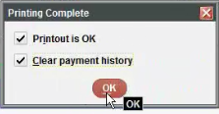

If everything has run correctly, the message “Payment history file cleared, appropriations saved,” will appear at the bottom left corner of the screen.

Note: If you have the Fund Activity report shows YTD appro history option set to "YES", Sierra saves the appropriation history, when you clear the Payment History file.

Choose the Close button to exit and return to the Funds tab.

