Use Existing Search can be used to change the search terms, add additional search terms, or rerun a search. For example, if a complicated search is needed, but the first search resulted in zero results. Instead of starting over, the current review file can be used to make changes.

First, a review file must already be created for this process to work. See How to Create a Review File to start the original search.

Go to Create Lists from the FUNCTION dropdown menu
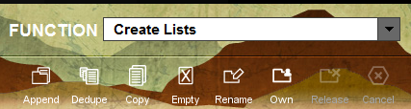

Highlight the review file. Note: if the original review file needs to remain unchanged, this process can be done using an empty review file.

Click Search Records.

There will be the warning message that you are about to over-write the contents. Click Yes.
Note: if using an empty review file this message will not appear.
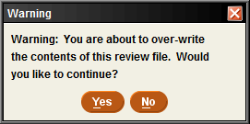

Click Use Existing Search.

This will bring up the list of review files. Highlight the review file. This will show the search that was used for this review file. It will also make the Use button active. Click Use.
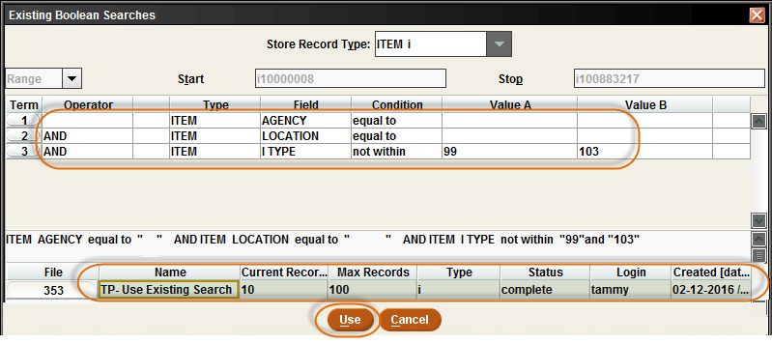

This brings up the original search. The Insert line and Append Line will be grayed out.
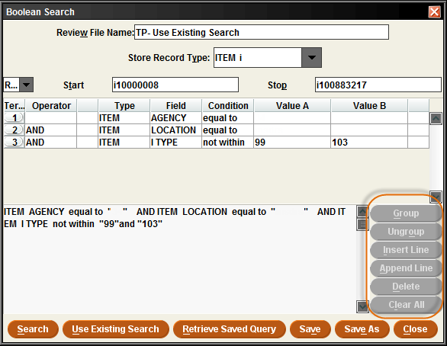
To add more search terms to the review file, click on one of the lines. This will make the Insert Line and Append Line buttons active. More search terms can be added by clicking on Insert Line or Append Line. To change any search terms click on the line, and double click on the box under the search term to bring up options to change any type, field, condition or value.
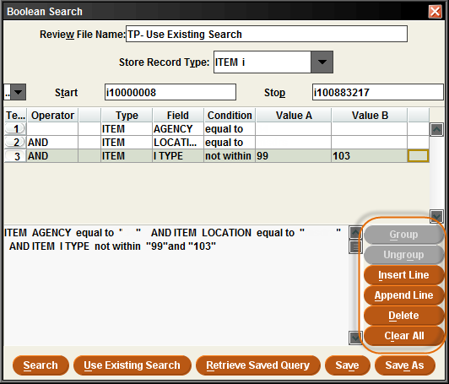
Append will put the line at the bottom. Insert will put a line at the top. Tip: Insert will also allow a line anywhere in the sorting fields once there are 3 or more lines.

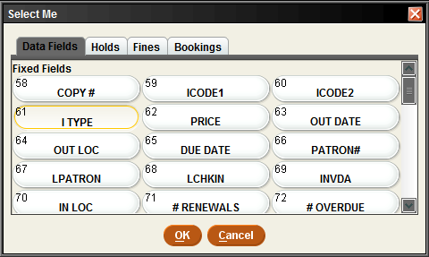

After entering new search terms or changing a search term, click Search to start the new search.

To find the review file, you might need to change Empty to Complete in the dropdown menu. Finding the review file can be done by File, Name, Login or Created [date/time]. Highlight the review file to view it. Double click on the file or click on Show Records to view all the items in the review file.
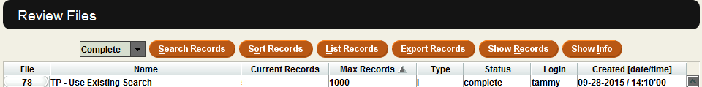

Review File Clean-up
If a new review was used, please remember to go back and empty the original review file that is no longer needed.
