Creating a Review File for Weeding – 2 options
Delete Records Function: this review file for weeding is a list created from scanning books or items you want to delete using the delete records function.
Option 1 – Create a Review File Using Index
1. Choose Create Lists from the Function list.
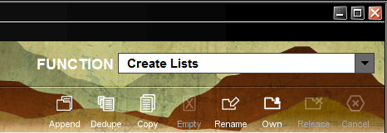

2. Choose an empty review file bucket that will match the number of items you want to delete.
3. Name your file name using the Create Lists Best Practices guidelines.
4. Choose Index drop-down list. Choose Barcode (b). Scan the barcode of one book you want to delete in both Index fields.
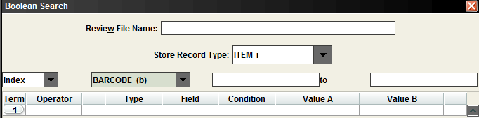

5. Without specifying any other criteria, click Search. Once one item has been done, you will be returned to the Review Files screen.

6. You can either highlight your review file and click on Show Records or double click on the file to bring up the Boolean Review File.
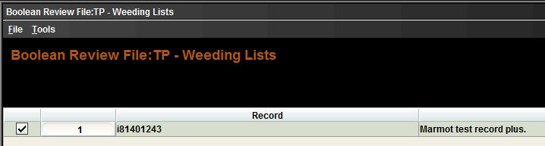

Option 2 – Create a Review File Using a Barcode Search

Uses steps 1 – 3 from Option 1
4. Choose Type - Item, Field - BARCODE, Condition - equal to, and Value A would be just one barcode from the cart of items you want weeded.
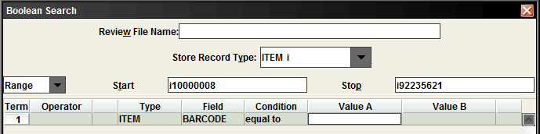

5. Click Search. Once the search is complete, you will be returned to the Review Files screen.

6. You can either highlight your review file and click on Show Records or double click on the file to bring up the Boolean Review File.

How to Add the Rest of your items from the weeding cart to the review file

1. Click on the Add button on the right side of the screen to start adding records to the list.
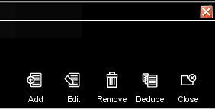

2. Change the dropdown menu to b Barcode to start scanning the barcodes of the books you want to add to the review file. If you decide to not add an item, click Close.
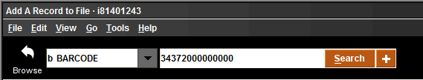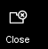

3. You would click on Use Item Record to include the book you want to add. The book will be added to the bottom of your list. Repeat steps 1 – 3 for each book.
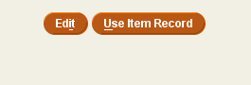

4. You can also Dedupe the records after the scanning to make sure you do not have any duplicate records. This will remove a duplicate records.
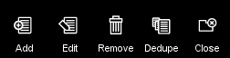

5. Once all items have been added to the weeding list, Close the Boolean Review File box.

How to Delete the Records from the Create List Review File
1. Go to Delete Records Function.
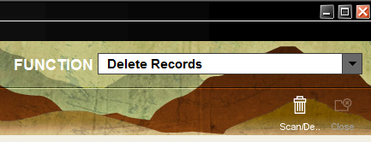

2. Find your review file with the records you want to delete. Click Start. It will give you two options.
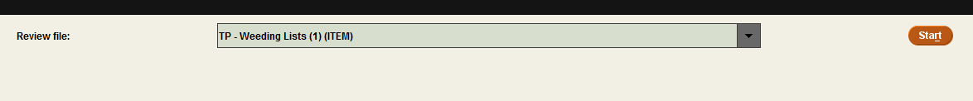

3. Pick the Choose Delete the listed ITEM record ONLY, and then click on Delete Records. You will get a pop-up box that warns you the action cannot be undone. Click, Yes.
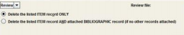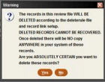

4. Review your Successful Deletions Box for any errors. Items not checked in or with holds will not be deleted.
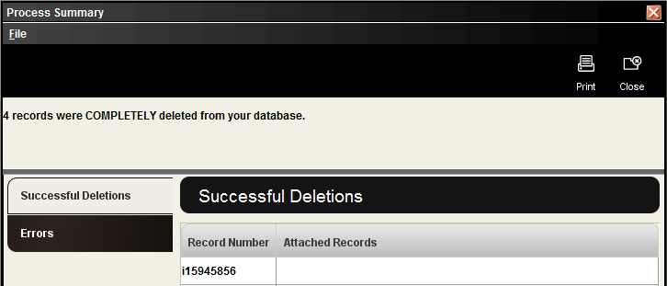

5. Close all boxes when finished. The list will stay in Create Lists Function until emptied.

Keep a record of the number of deletions for the year. You will probably need them for your statistics.

