Click on Create Lists from the Function menu.
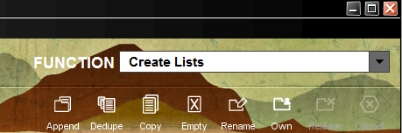

Find the review file to be exported and highlight it. In this example, we are using an Item Type Review file. Items have the i in the Type box. A patron review file will have the letter p. A bibliographic review file will have the letter b. Click on Export Records.
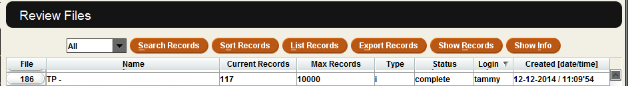

Decide what fields to export. This will be the way the review file will be displayed in Excel. Double click in the box under Type to get the Select Me box. The review file is an item review file, so pick ITEM for Type. Click OK.
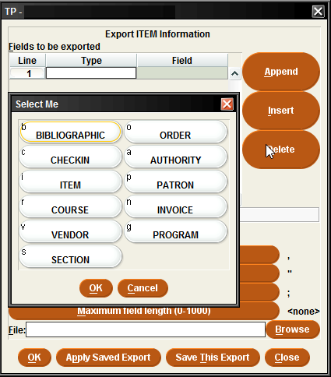
The Type is now ITEM. Double click in the box under Field, this will bring up the Select Me box again. Pick the information to be shown about the item. For example, CALL #. Click OK.
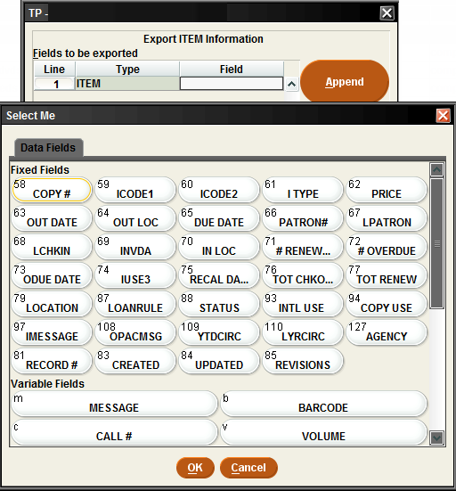

Repeat this process until all the information is included that will be exported. Click on Append to put a line at the bottom. Click Insert to put a line at the top unless there are 3 or more lines, after the Insert can be included wherever the cursor is located.
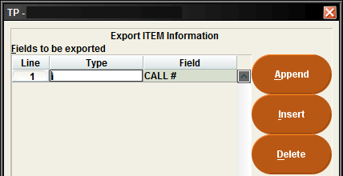

Note: The title of the item can only find that in BIBLIOGRAPHIC.
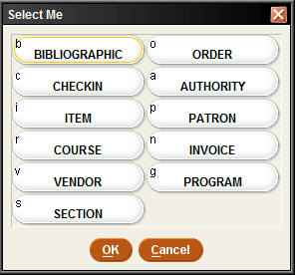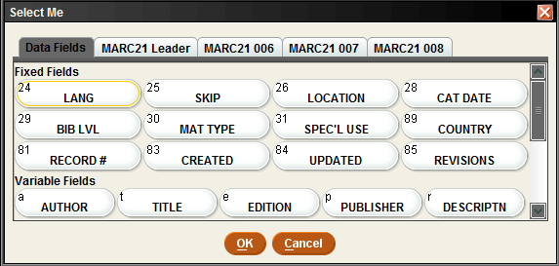

Once all the Fields have been chosen to be exported, click Browse.
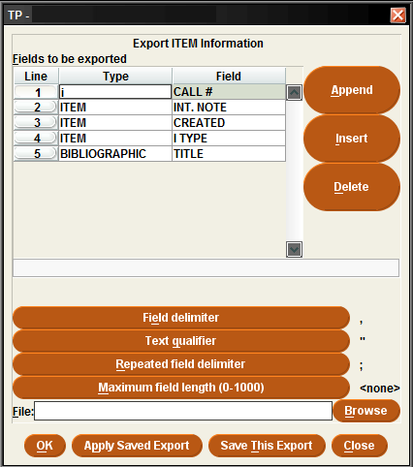

This will open the Choose output file located on the computer or laptop.
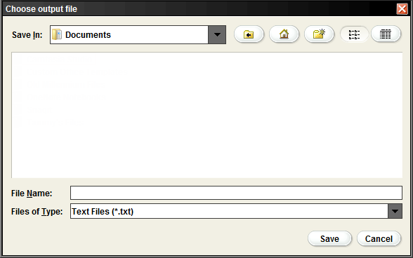

We are going to save this file with a .csv extension to save a few steps when exporting to Excel.
Pick where to save the file from the Save In: dropdown. Change the Files of Type to All Files. Make sure to name the file ending in .csv. Click Save.
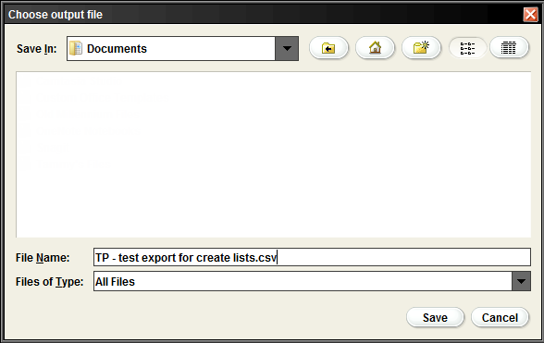

This will automatically put the file in the file box next to Browse. Click OK.
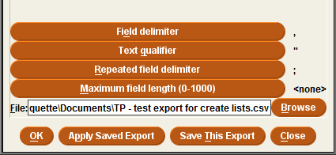

This will bring up the Exporting message. The message will go away as soon as the file has exported to the destination on the computer or laptop.
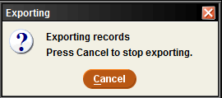

Viewing the Excel Spreadsheet
There might be few problems with the display of the BARCODE and DATE fields on the spreadsheet.
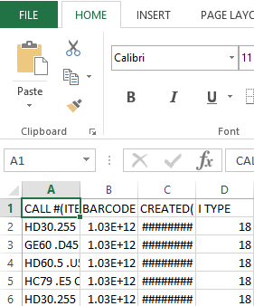
Tip: to fix the CREATED DATE or any other date field widen the column by putting the cursor on the side edge of the column and dragging it until the entire date can be seen, or double clicking will widen the column.
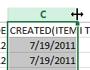
Excel does not automatically change your BARCODE field from General to Number. Highlight the BARCODE column.
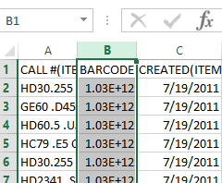
Tip: Click on the dropdown menu on the Number field to change General to Number.
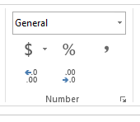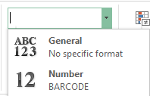

The BARCODE has change from 1.03E +12 to a number. However, it will probably have a few extra decimals at the end.
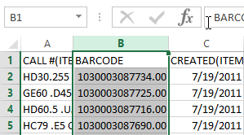
Tip: Click on the Decrease Decimal twice to get rid of the decimal points.
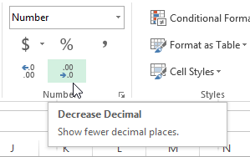

The BARCODE column looks normal now.
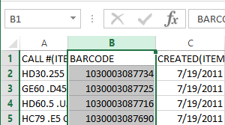

Sorting an Excel File
Sorting the spreadsheet helps to find important information about the items in the review file. Highlight the top row of your columns to begin the sorting process.
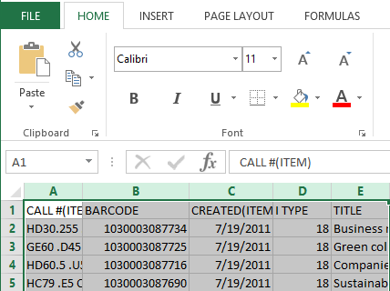

On the HOME Tab is the Editing box.
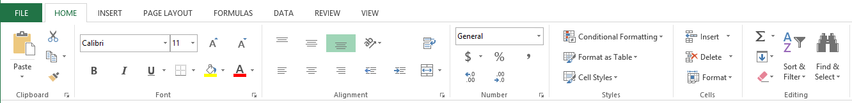

Click on the Sort & Filter drowdown arrow. One option is to use the Custom Sort to sort columns.
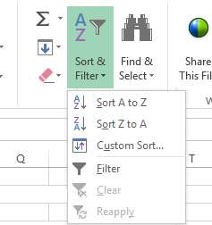

Once the Custom Sort has be chosen, the Sort box will appear. This will let sorting of any one of the columns by any of the fields that has been exported. Change the order for A to Z or Z to A. Click OK.
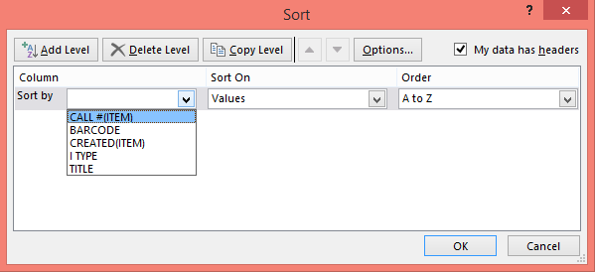

Another option is the Filter instead of the Custom Sort. Filters sort each column individually.
Highlight the top row. Click on Sort & Filter. Click Filter. There is a dropdown arrow for each column.
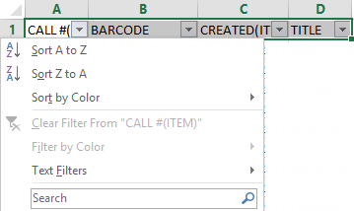
Sorting each column will sort the entire spreadsheet.

Saving an Excel Spreadsheet

Click File and Save. Depending on what version of Windows, change the CSV (Comma delimited) to either Excel Workbook or Excel 97-2003 Workbook. Click Save.
