Merging Review Files in Create Lists can be done when there are two similar files that can be combined as one review file.

Choose Create Lists from the Function list.
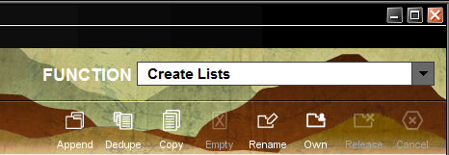

Choose one of the two review files to be merge by selecting its row. You will notice the file has only 1 entry.

Choose Tools and Append or the Append tool located on the Function screen.
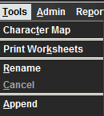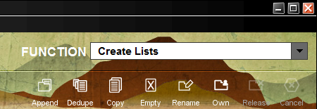

Create Lists displays the Boolean Search window.
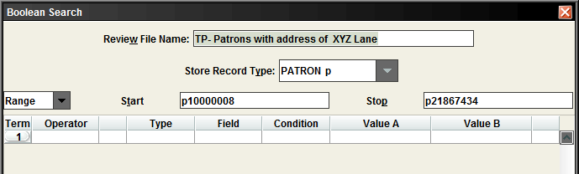

Choose Review from the Range drop-down list and select the review file to be merge into the current review file. The file has two entries.
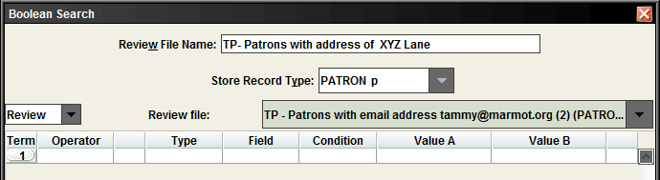
Tip: Type the first letter of the review file to get to the file faster. Click on the review file.

Choose the Search button.

Now the review file has 3 entries.

(Optional) Remove duplicate records by clicking Dedupe.
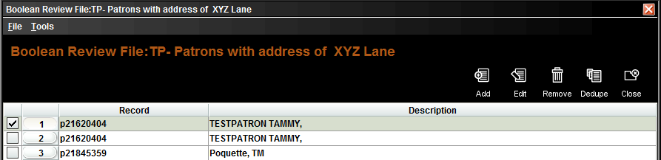

Remove one of the original files, since there will be two files.

