Macros in Sierra allow customization of keyboard function keys to have predefined values or shortcuts that help make working with Sierra more productive. Macros are separated by user account so each user can have a different set of macros. A common use of macros is to make a macro that will navigate between Sierra functions at the press of a button instead of multiple mouse clicks. See member generated macros for other macro use ideas.

Creating Keyboard Shotcuts Using Macros for Sierra Functions
To set up Marcos you would go to Admin, Settings and MACROS.
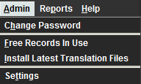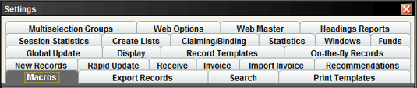

Use either No Modifier, ALT, CTRL or SHIFT to begin using Marcos. In this example, we are using the No Modifier and F1 – F3. The macros for F1 – F3 look intimidating at first. However, the secret to macros in Sierra is to know what each letter means. Here are just a few examples of ways to use macros to create keyboard shortcuts for Sierra functions. F1 macro will bring us to the Check Out (Circulation Desk) function. F2 macro will bring us to the Check-In (No Patron) function. F3 macro will bring us to the Notices function.
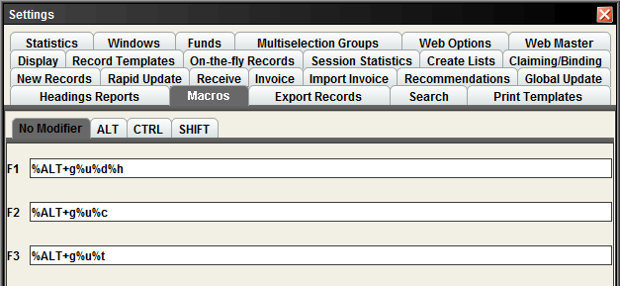

Check Out (Circulation Desk) using No Modifier – F1
The %ALT is the same as pressing the ALT key. Keyboard codes must be enclosed in percent signs in order to work. The system also uses the plus sign '+' for non-alphanumeric/alphanumeric key combinations.

%ALT+g%u%d%h
Always start the macros with %ALT+ when using No Modifier, ALT, CTRL or SHIFT.
The g is for Go. The u is for Circulation. The d is for Check Out (Circulation Desk). The h is for Check Out. Pressing the F1 key on the keyboard should automatically bring you to Check Out (Circulation Desk) function.
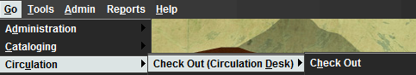

Note: If the Due Slip Printing box pops up, you will have to click Yes or No, before you can get to the Check Out function.
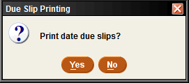

Check In (No Patrons) using No Modifier – F2
%ALT+g%u%c
Always start the macros with %ALT+ when using No Modifier, ALT, CTRL or SHIFT.
The g is for Go. The u is for Circulation. The c is for Check-In (No Patron). Pressing the F2 key on the keyboard will automatically bring you to Check-In (No Patron) function.
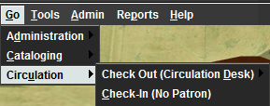

Notices using No Modifier – F3
%ALT+g%u%t
Always start the macros with %ALT+ when using No Modifier, ALT, CTRL or SHIFT.
The g is for Go. The u is for Circulation. The t is for Notices. Pressing the F3 key on the keyboard will automatically bring you to the Notices function.
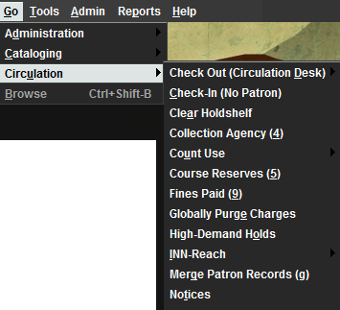
You can copy any of the macros from this document to into the Sierra macros fields.

Tip: use the Cltr and V key to paste any of the macros from this document into Sierra.

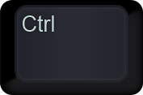 and 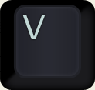
Other examples for Macros for Sierra Functions using No Modifier
Search/Holds – %ALT+g%u%h (g for Go, u for Circulation and h for Search/Holds)
Cataloging - %ALT+g%c%g (g for Go, c for Cataloging and g for Catalog)
Create Lists - %ALT+g%d%l (g for Go, d for Administration and l for Create Lists)

The same macros can be created using the ALT, CTRL and SHIFT. Using these macros means the Alt, Ctrl or Shift keyboard keys will need to be pressed before pressing the F1 – F12 keys.
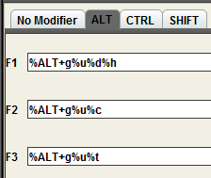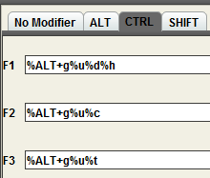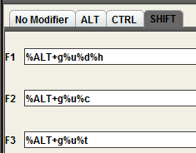
Click Save Settings and OK when finished. The new macros can be used right away.