Searching Items in Search/Holds
Click on Search/Holds in Function dropdown menu.
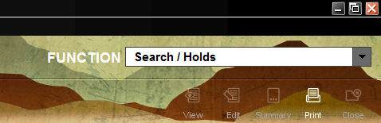

Select the index you would like to search; such for t TITLE, b BARCODE, etc. You can pick any of the index searchs from the dropdown menu. Use the scroll bar to see more options.
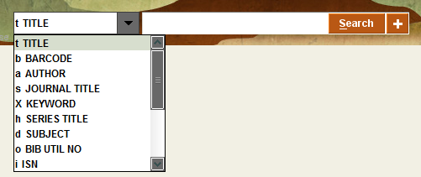

There are many different ways to limit a search. Limit by your location by clicking on the plus sign next Search.

This will bring up the Limit box. You can click on “WHERE item is located” to get a list of all the location codes of member libraries. Click on your library or a specific location code. By clicking on the box to “Apply limit to all searches,” the settings will stay until you change them or until you logout of Sierra. Remember to click on “Apply.”
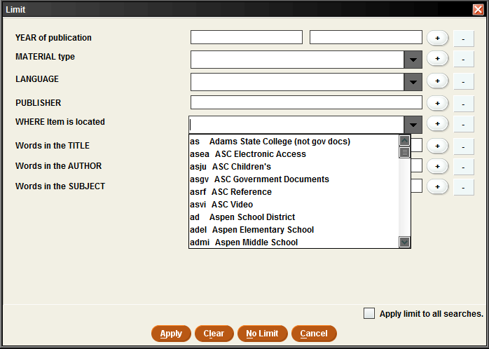
Depending on the index that was chosen, type in a search term or title, barcode, etc. In this example, we are using the index d Subject and the search term “gardens.” At the bottom of the page is a list of subjects and entries. 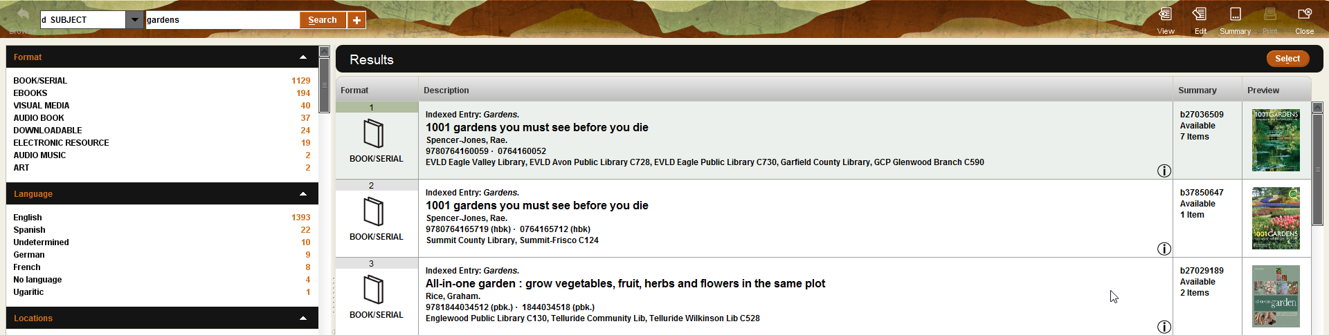
The search resulted in 299 subjects and 1447 entries. This will be explained more with limiting.

Limiting – Format, Language, Locations and Phrase

On the side bar of your results page will be more ways to limit a search. You can limit by Format, Language, Locations and Phrase.
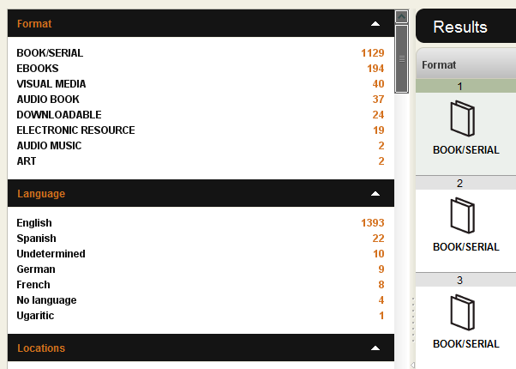

Click on the white arrows to expand or shrink each criteria. We mentioned the 299 Subjects and 1447 Entries earlier. Looking at the Available at Library criteria, there are only 1148 entries. The difference in numbers is usually caused by items that are not physically at the library such as EBOOKS, DOWNLOADABLE materials and ELECTRONIC RESOURCES.
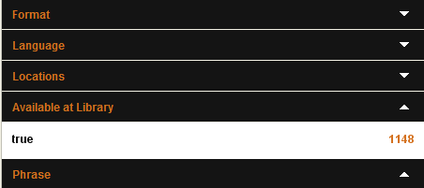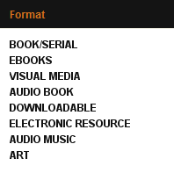

When an item is not available for check out or a hold it will have the words “Not Available.”

Mousing over the will show information about the item.
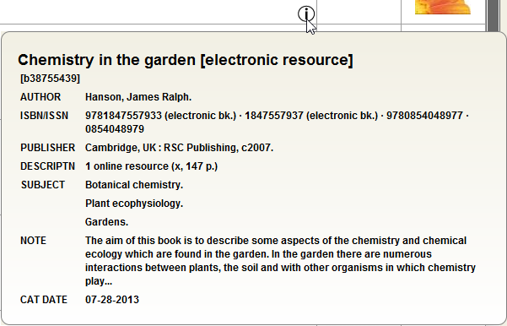

In this example, the limits have been set to BOOK/SERIAL, English, all Locations, Phrase “Gardens.” We have gone from 1148 entries to 75 entries available for check out or holds.
You can clear a limit by clicking on the .
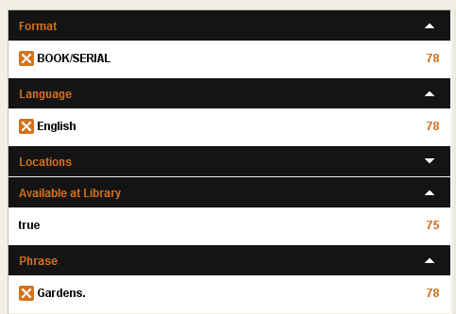

To see more information about an item, highlight it by clicking on the item. Click “Select.”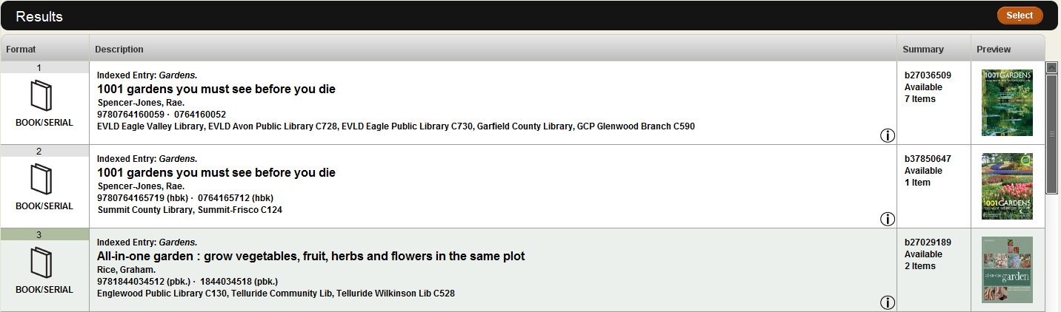
This will bring up the item record where you can see which member libraries have the item. You can also see the item if the item is checked out or On SHELF.