The majority of your holds will be patron placed holds (PPH) through Pika. However, on occasion a staff member might need to place a hold for the patron through Sierra.
Click Search/Holds function from the dropdown menu.
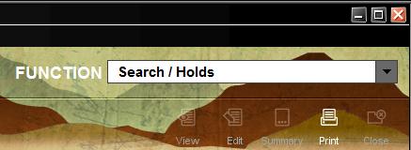
Type the title of the item you would like to place a hold on for the patron. You can narrow your search by Format, Language, Location and Phrase. 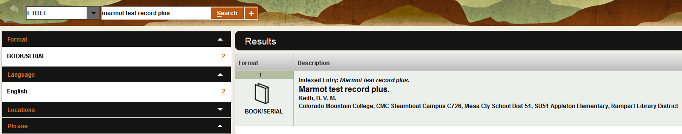
You can click on the Select button or double click on title of the item to get access to place it on hold.
If the record has more than one item attached, you will see multiple listings. Click on the item you want the hold placed for the patron. Click Hold Selected Item to place an item level hold.
Clicking on the Hold Selected Item will put an item level hold on the item. 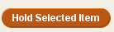

The Search for Patron pop-up box will appear. You can enter the b PATRON BARCODE, n NAME, u ID (unique ID), f FAMILY ID or .RECORD # for the dropdown menu.
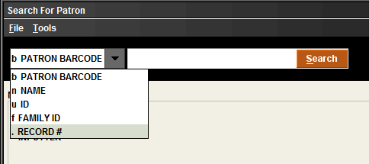
Tip: you can find the .Record # for the patron when editing their account.

Once a format to look up the patron information has been decided, click Search to place the hold.
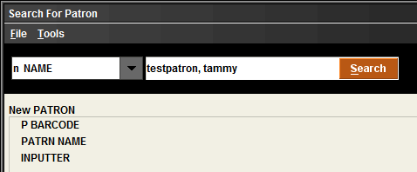

The Place an Item-level Hold pop-up box will appear. The Pickup Location will be the location of your library. You can change the Not Wanted Before: & Not Wanted After: to dates that will narrow down how long the patron is willing to wait or needs the item. The Hold Note: is for any information you want to share with your staff about the hold or patron. Click OK. This will put the hold on the patron’s account.
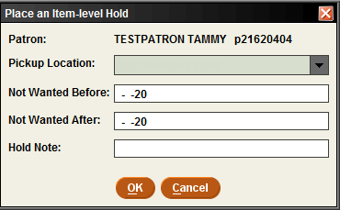

You can verify your hold a few ways. One way is to use the Search/Holds function. Type in the title of the item. Clicking on the Item-Level Hold tab will allow you to see the item information.
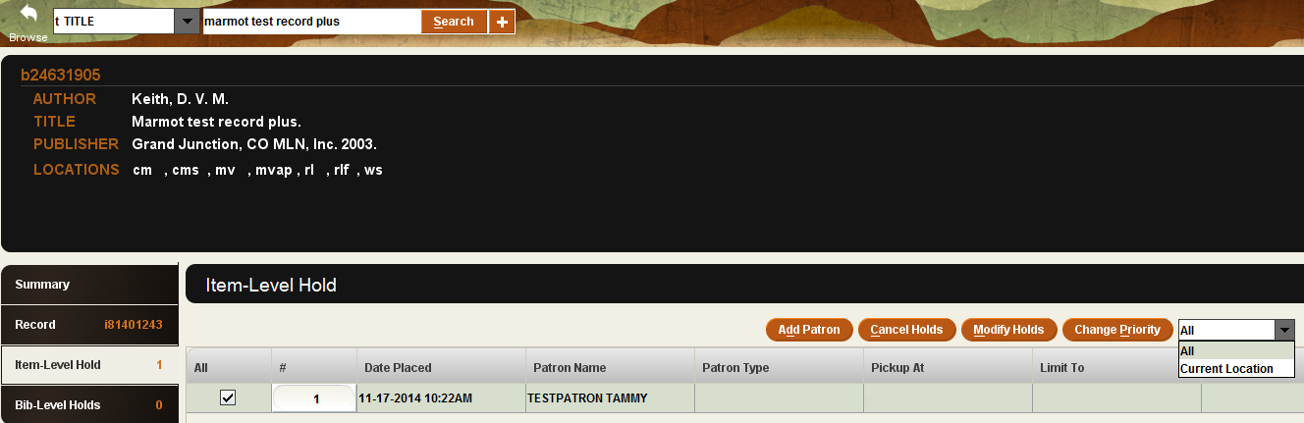
Clicking on the box next to the item will allow you to Add Patron, Cancel Holds, Modify Holds and Change Priority. There is a dropdown to change from All to Current Location.
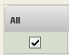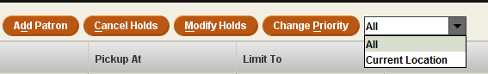

You can also verify and/or view the hold on the patron’s record. Click on the Check Out (Circulation Desk) function in the dropdown menu. Enter the patron’s name or barcode. Click on the Holds tab to see the item. Clicking in the box under All will allow you to Add Holds, Cancel Holds, Modify Holds and View Cancelled Holds from this screen.
