TABLE OF CONTENTS
(Order is related to location within the Check Out (Circulation Desk) Function)
Check out (Circulation Desk) Page
Checking out Items 1-3
Changing Due Date 3-4
Add message (Item Message) 4
Checked-Out Items Tab 5
overdue items 5
renew items 6
Claim Returned 6-9
mark items Lost 9-10
Holds Tab 11
Add Holds 11-13
Cancel Holds 13-14
Modify holds 14-15
View Cancelled Holds 15
Fines Tab 16
Collect Money 16-17
Waive Charges 17-18
Add Charge 18
Fines Paid 19
Patron Notes 19
Check In Tab 20

Click on Check-Out (Circulation Desk) from the dropdown menu at the upper right corner of the Sierra program.
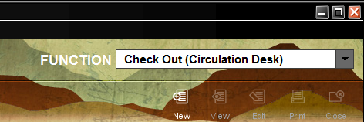

There are several options to bring up the patron’s record.
1) Scan the patrons’s barcode. Type in the patron’s barcode number as well.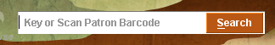
2) Type the letter “n” and the patron’s lastname and first name.
3) Click on the Seach box to bring up the Find a patron screen. Use the dropdown to either enter the b PATRON BARCODE, n NAME., u ID (unique ID), f FAMILY ID or .RECORD #. Type the patron’s lastname and first name when using the n Name dropdown.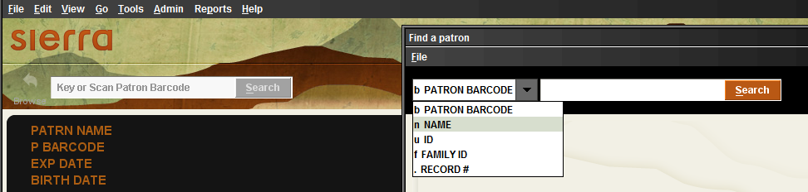
Entering the patron’s barcode or name into the system should retrieve the person’s account. Fields displayed in the patron’s record will depend on the patron template.

Checking Out Items
The P Type is decided by your library.
The P Barcode would have been supplied by your library.
The patron EXP DATE is decided by your library.
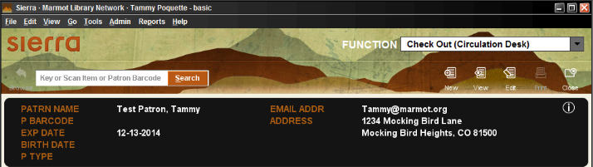

Hint: hovering over the in the corner of the patron’s account is a quick way to view the patron’s account information. Included will also be any messages or notes that your staff had added. This is one of the ways to see multiple messages or notes on a patron’s account. The other way is to click the Edit button to see the patron’s entire account information. Tip: This can be configured to show different information per login. Contact Marmot to make the change.
This is a sample of what the information box will look like when hovering over the
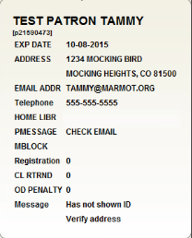
Next, scan the barcode of the item or items that the patron would like to check out. 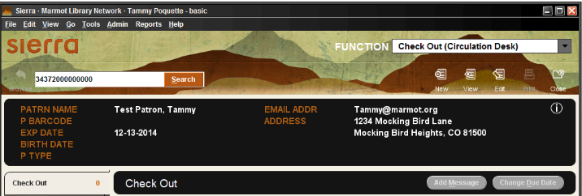

Once the item is scanned, the item’s barcode, title, and due date will display on the screen. The information from the item is in the Check Out tab.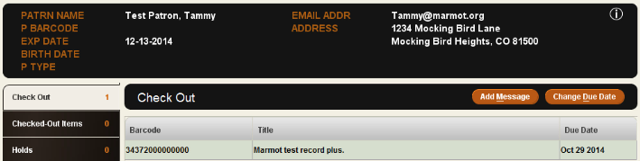
At this point scan the next item or Change Due Date of the current item. Note: the Add Message will add a message to the item. This will not add the message to the patron’s account.
Top of the page

Changing the Due Date
Change Due Date Button
We are going to use the Change Due Date to change when the patron can return the item. Changing the due date is a policy issue that may need to be discussed with a supervisor. 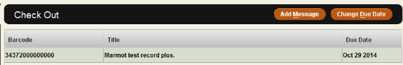

The Change Due Date calendar box will pop-up. Tip: clicking on the >> or << will change the year of the due date. Clicking on the > or < will change the month. You will also need to click on a specific day to complete the Due Date change. The October 29 2014 information will remain the same until a new date is picked. While clicking on the arrows, the changes to the date can only be seen in the box containing the October 2014. Click OK.
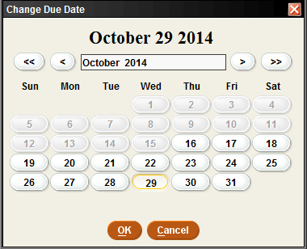
Top of the page

Add Message Button (Item Message)
This will add a message to the item and not the patron. 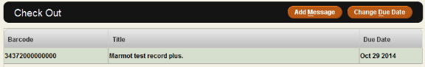

If staff clicks the Add Message this is the screen that will appear. If a message is accidentally put in this field, the message will display during check in. This field can only be removed by editing the item record.
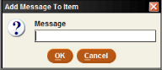
Top of the page

Checked-Out Items Tab

During check out there are other fields on the left side of the patron check out screen under Check Out. This is where checked out items, holds and fine can be viewed. A hold or a fine can be added to a patron’s record from these tabs. You can also check in a patron’s books and link patrons.

Clicking on Checked-Out Items tab will display any items the patron had previously checked out. Included are the item(s) barcode, title and due date. Renew, Claimed Returned, Marked Lost Items and Change Due Date can also be done from this tab.
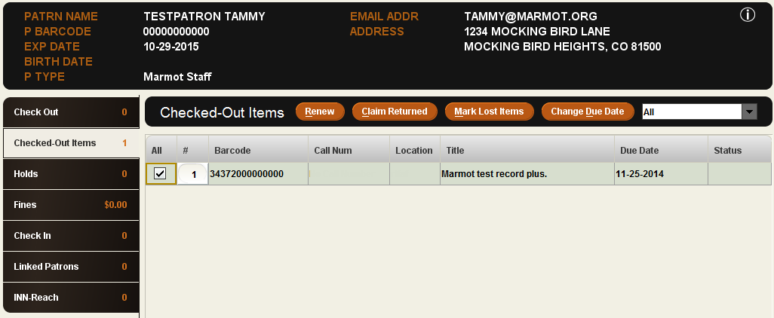
Top of the page

Overdue Item
The Checked-Out Items tab will be a different color when an item is overdue or billed. Click on the tab see what item(s) is overdue or billed. The Status of the item will be OVERDUE. Clicking on the box under All will give access to Renew, Claim Returned, Mark Lost Items or Change Due Date.
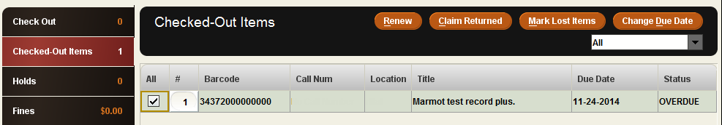
A billed item will have the Status of BILLED 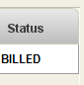

Top of the page

Checked-Out Items Tab
Renew Button
Click this button to renew an item a patron had previously checked out. Click Renew.

Depending on the due date and the renewal policy for a library, the message “The item was renewed” may pop-up. This will also put the word *RENEWED in the Status box.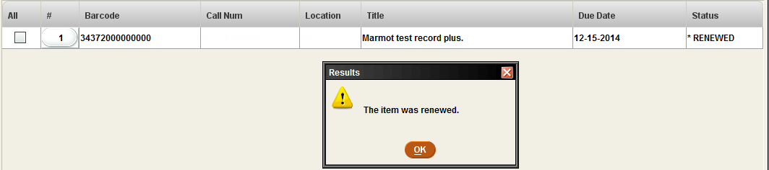
If a patron has tried to renew the book more times than allowed, the following message will pop-up.

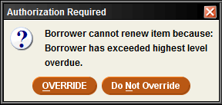
If it is too soon to renew the item, the following message will pop-up.

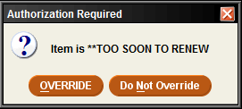
Top of the page

Claim Returned Button
A claim returned can be used when at patron claims to have returned an item that is still checked out on their account. Click on Claim Returned.

The Claims Returned On calendar will pop-up. Click on the date they claimed to have return the item and click OK. If the patron does not remember the date, click the Blank Date.
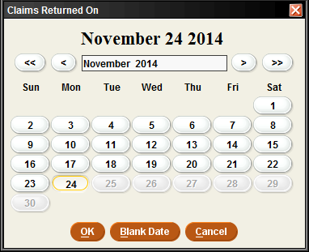

The Change Item Status pop-up box will appear. It is best to click the “Leave items checked out (send overdue notices) and change status to CLAIMS RTRND” button.
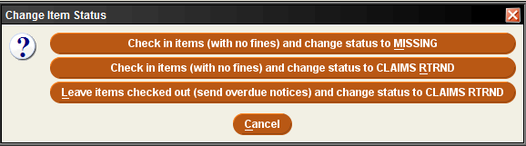

The following screen message will pop-up, “The item was claimed returned.” The Status of the item will change to CLMS RETD.
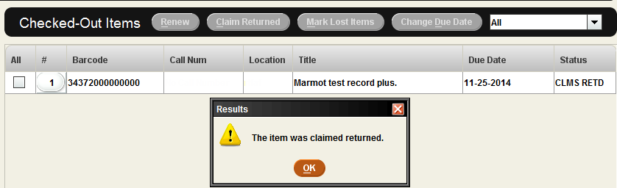

The patron record will have a number listing for each CL RTRND (Claim Returned).

The item will have the STATUS of z CLMS RETD.

The item will also have an INT. NOTE (internal note) stating when the book was marked Claims Returned, and date (unless you choose Blank Date on the calendar) and the patron number.

If the book is found by your staff or the patron, you would check the book in using the Check-In (No Patron) function.
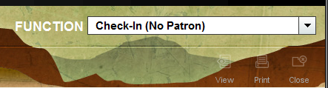

Scan the barcode of the item.
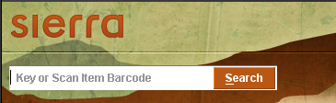

The following message will pop-up, “Item status is CLMS RETD. Clear it?” Click Yes.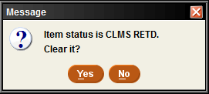

Clicking Yes, the following screen will display the the Status as Claimed returned. 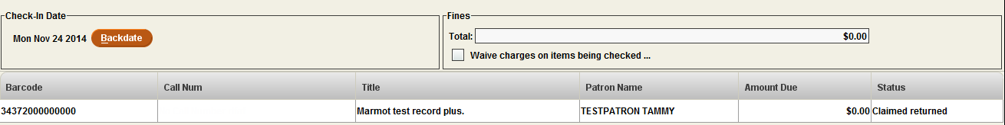

The item STATUS changed from CLMS RETD to – ON SHELF. The INT. NOTE will be gone from the item.
Top of the page

Mark Lost Items Button
Mark Lost Item can be used when a patron has lost the item that is still checked out on their account.
Click Mark Lost Items.

Clicking on the Mark Lost Item button the Mark Lost Items pop-up box will appear with the Item Cost, Processing Fee, Billing Fee and Amount. Click Add Bills, Update Bill, View Item or Cancel.
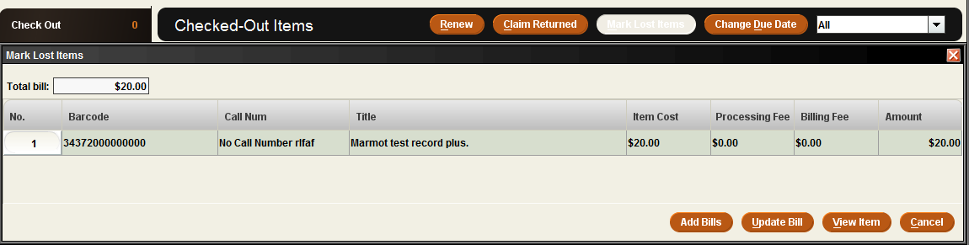

Clicking on Add Bills will put the amount in the Fines tab of the patron’s record. The Status of the item will change to Lost.
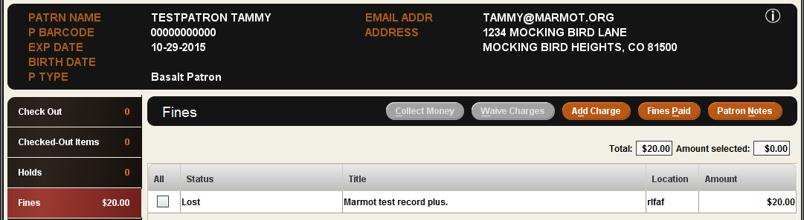

If the item is found by the patron or your staff, you will get the following message during Check In. Click OK.
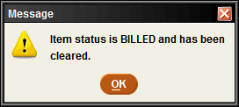

This will change the item’s Status from Billed to Not Checked Out.
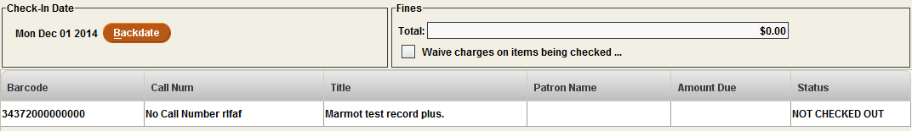

The INT. NOTE. (Internal Note) may still be in the item record. This note may need to be deleted manually.
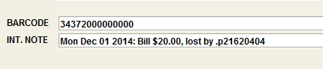
Top of the page

Holds Tab
Click on the Holds tab to place a staff placed hold on an item using Add Holds. Other buttons are the Cancel Holds, Modify Holds and View Cancelled Holds. Click on the View Cancelled Holds to see the information regarding any hold that was cancelled.
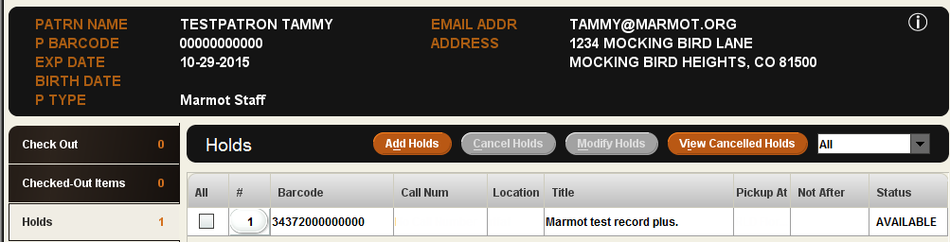

The Cancel Holds and Modify Holds become active when the box below All is clicked. Messages that it is too soon to renew or there are no more renewals may happen when renewing an item.
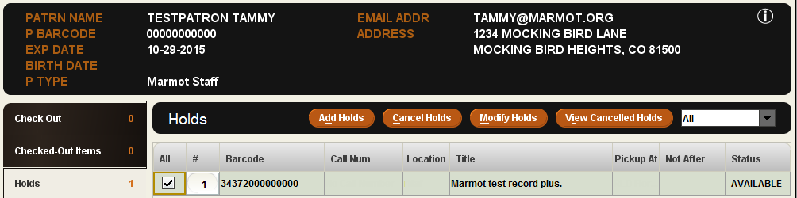
Top of the page

Add Holds Button
This is one way that staff can place a hold on an item for a patron. Click Add Holds.

This will bring up the Browse function to look for the book to place the hold. Enter the title of the item.
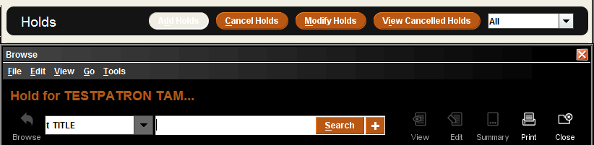

Click Select to view the item. Double clicking on the item will also open the record.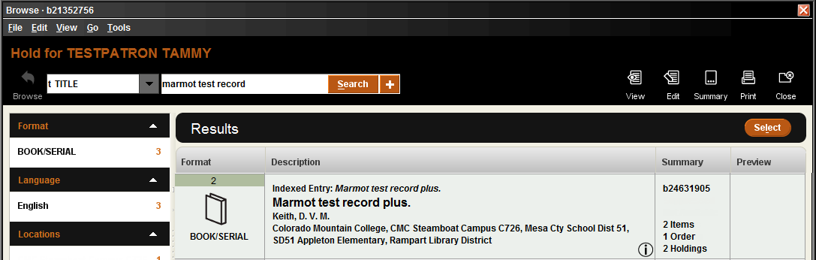

All the other libraries that have items attached will be listed. Click on the item for your library, or the specific item such as certain disk for a DVD set, or a certain book from a series from another library. Click on the Hold Selected Item to place an item-level hold.
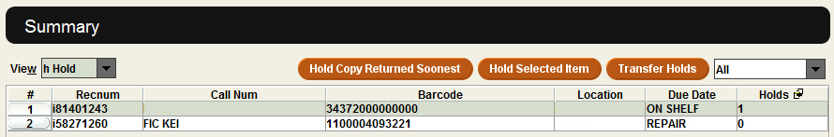

The Place Hold for an Available Item pop-up box will appear. Click Place hold.
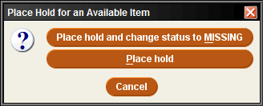

This will bring up the Place an Item-level Hold pop-up box. The Pickup Location will be your library. The Not Wanted Before or the Not Wanted After is for a date when the patron wants the item, or no longer needs the item. Click OK.
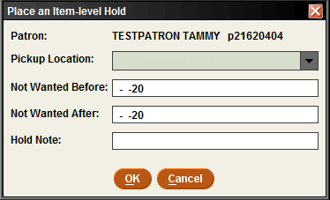
Double clicking inside the white box next to the Not Wanted Before and Not Wanted After will bring up the Select Date calendar.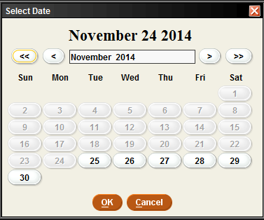

Top of the page

Cancel Holds Button
This is one way a staff member can cancel a hold for a patron. Click Cancel Holds.

Depending on why the hold is cancelled, pick Cancel hold and change status to MISSING, or Cancel hold. For this example, we will click on the Cancel hold.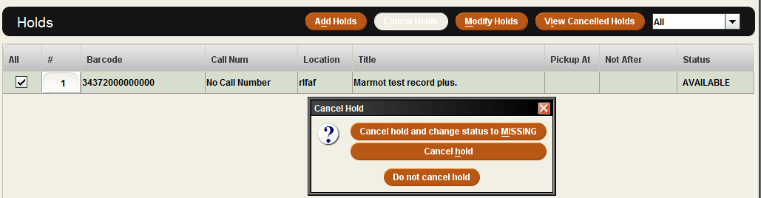

The Question pop-up box will appear with the message, “Print hold cancel notice?” Clicking Yes or No depends if a library wants to keep a record of a cancelled hold.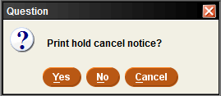
Top of the page

Modify Holds Button
This is one way your staff members can modify a hold for a patron. Click Modify Holds.

The Individually Modify Holds pop-up box will appear. The Not Wanted Before date, the Not Wanted After date are dates when the patron wants the item, or no longer needs the item. A Hold Note can be added to share information. The Pick Up By date is general set by loan rules. Click OK.
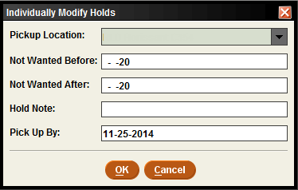
Double clicking inside the white box next to the Not Wanted Before, Not Wanted After or Pick Up By will bring up the Select Date calendar.

Top of the page

View Cancelled Holds Button
This is a way to view cancelled holds on a patron’s record. Click View Cancelled Holds.

This will bring up a list of any cancelled holds. Click Print, OK or the X to get out of the information.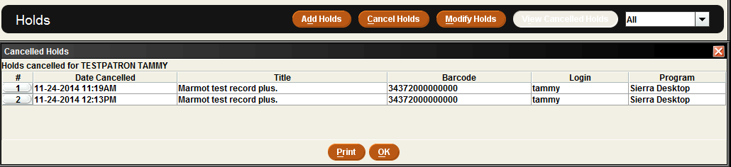
Top of the page

Fines Tab
Clicking on the Fines tab will display fines on a patron’s record. If the patron owes fines the tab will be a different color. Click in the box under the All to gain access to the Collect Money, Waive Charges, Add Charge, Fines Paid and Patron Notes buttons.
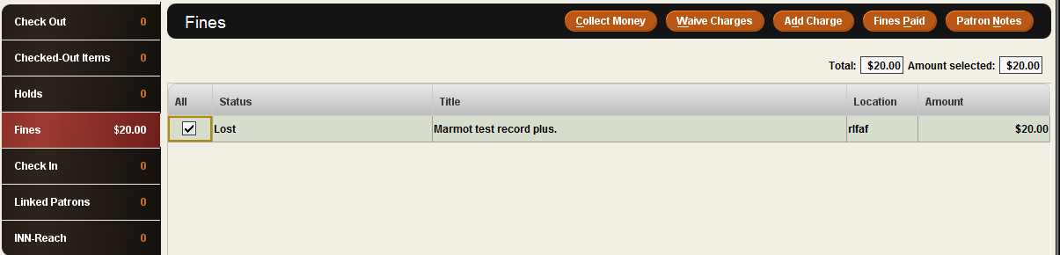
Top of the page

Collect Money Button
Collect Money button will allow partial or total payment from a patron.

If the patron would like to pay the fine now, click the Collect Money button. This will bring up a Collect Money pop-up box. Either click OK or change the amount depending on what the patron pays. In this example, we are going to pay half of the amount owed.
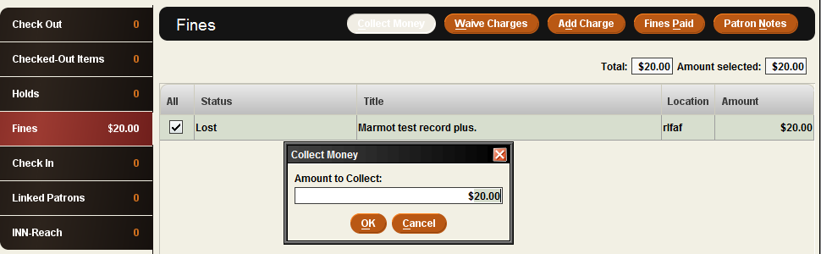

The system is asking us if we want to Waive remaining fines? We are going to click No.
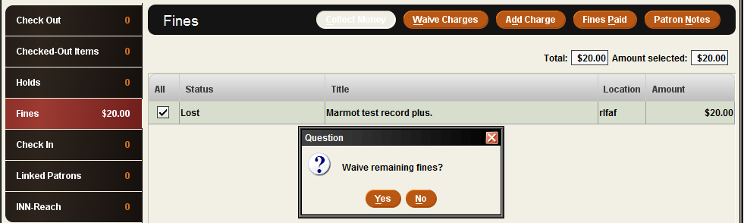

The system will generate a receipt stating how much was paid and how much is owed. The receipt can be printed for the patron.
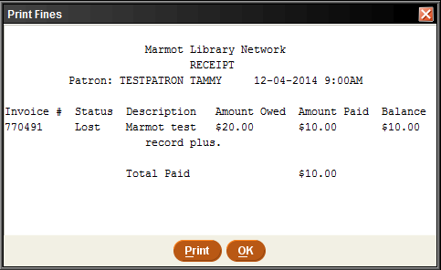
Top of the page

Waive Charges Button
Waive Charges can be used for an amnesty day.

Click on Waive Charges. The Question pop-up will appear with the message, “Waive selected fines?” Click Yes or No.
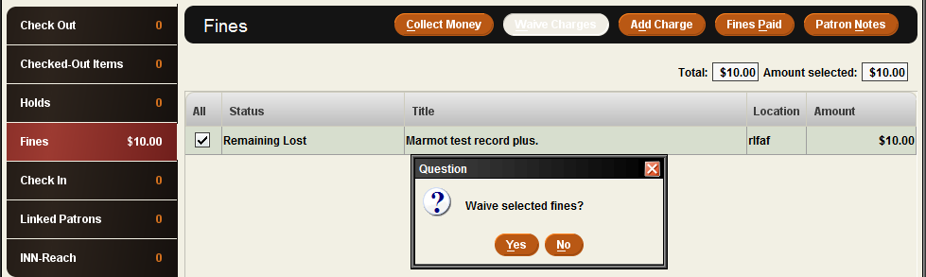
Top of the page

Add Charge Button
The Add Charge will bring up a pop-up box with predefined fines that can be added to the patron’s record.

Click on Add Charge to bring up the Add Charge pop-up box. Click on the arrow in the predefined charges to pick a new charge. Use the scroll bar to see the list of charges that can be added to the patron’s record. The information will be placed in the Reason box. The Amount will added to the patron’s record once OK is clicked.
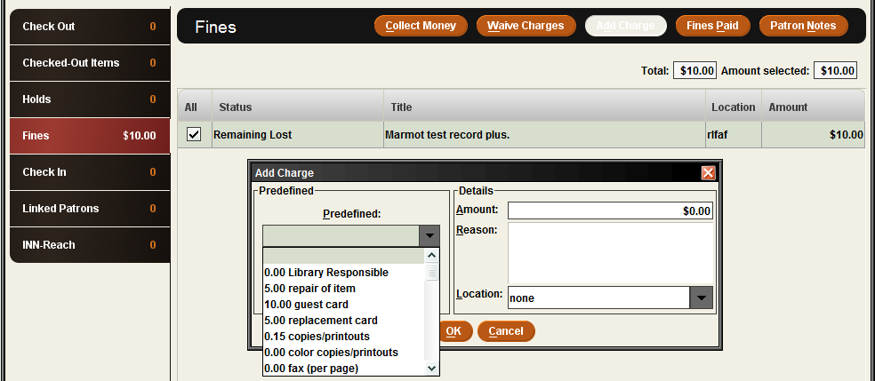
Top of the page

Fines Paid Button
Fines Paid will show the history of any payment transaction on the patron’s record.

Click on Fines Paid to bring up the Fines Paid pop-up box. The choices are Print, View Fines, View Items or Close. Tip: Clicking on the item will make the View Fines and View Item buttons clickable.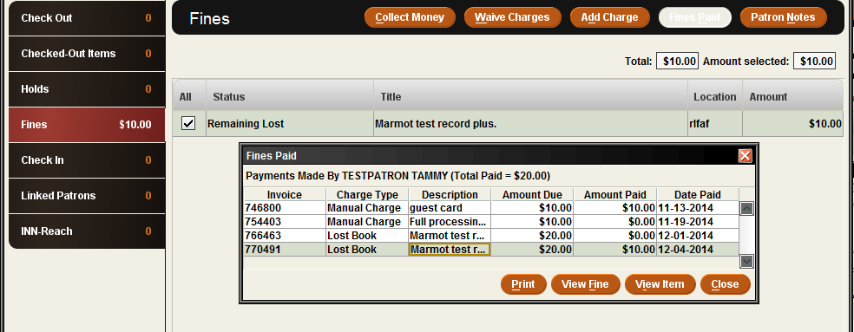
Top of the page

Patron Notes
This is one way to view any notes associated with a patron. It is helpful when in the Fines tab to see any notes associated with any lost items.

Clicking on Patron Notes will bring up the Patron Notes pop-up box. This will show any notes related to this patron.
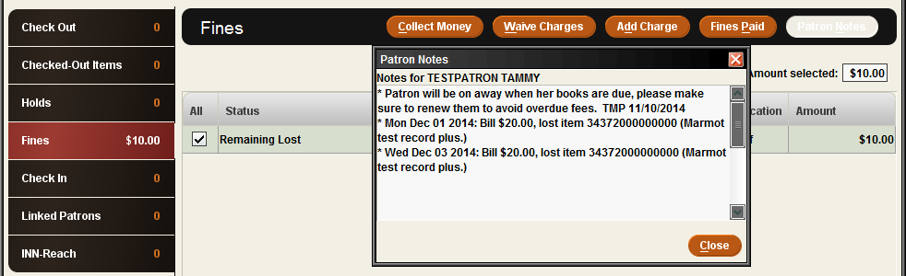
Top of the page

Check In Tab
Clicking on Check In will allow an item to be checked in that is on a patron’s account. Backdate, Waive Charges, Collect Money or Print receipt are also available from this screen. Note: The Check In tab can be used to check in other patron items. The system will automatically switch from the current patron to the new patron. However, it is better to use the Check-In (No Patron) function to check-in items.
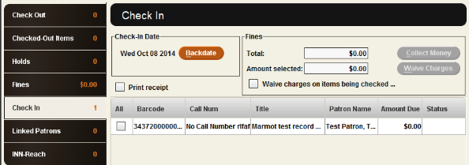
Top of the page

Linked Patrons and INN-Reach will be discussed in other documents.

