Checking in Items with no Backdate or Fines Waived:
Click on Check-In (No Patron) from the dropdown menu at the upper right corner of the Sierra program.

Scan the returned item or items in the Search box.
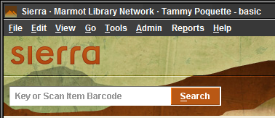
The system my display the following message for an item with a hold placed on it:
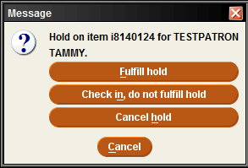
Choosing Fulfill hold the system may display the following message:
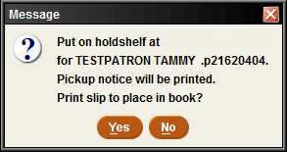

Check In Items with Backdate and Fines Waived:
The option to Backdate an item will remove any fines that would have accrued while a library was closed. Click the Backdate button before scanning an item. Clicking on Backdate will bring up a calendar.
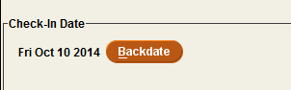
Click on the date you want to Backdate an item to clear the fine. Click OK.
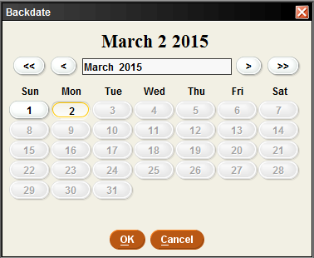

Another option to remove a fine is to click in the box next to Waive charges on items being checked … to waive fines accrued while a library was closed. Click on waive the charges before scanning an item.

Once the book is scanned the Barcode, Call Number, Title, Patron Name, Amount Due and Status will be listed. 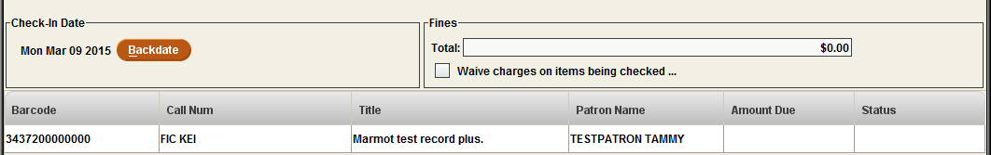

Click Close at the top of the screen once all the items are checked in.
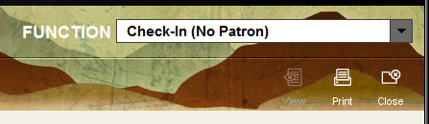
Messages you may encounter during check in with Patron Placed Holds (PPH):
Requested by .p (will have the patron number) for pickup at “ ” (will have the initials for the library, their courier code and library name). Checkin item? Pick Yes, No or Print This Message. 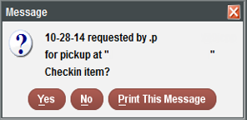

Hold on item i (will have the item number) for (will have the patron’s name). Click Fullfill hold, Checkin, do not fulfill hold, or Cancel hold.
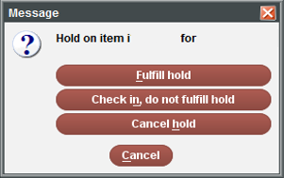

Item has HOLD to be picked up at (will have the initials of the library, the library branch and their courier code). Print transit slip? Pick Yes or No.
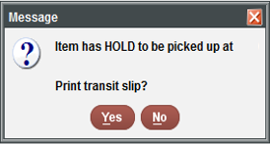

Put on holdself at (will list the name of the library and their courier code) .p (will have the patron’s number). Pickup notice will be printed. Click, Set status to: IN TRANSIT to (will have library name and their courier code), or ON HOLDSHELF or Cancel.
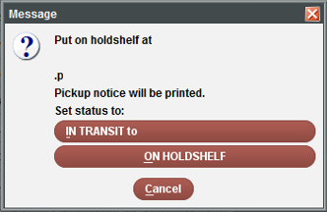

REMOTE SITE item from (will be the library name and courier code), requested by (will be the patron’s name). Print slip to place in books? Click Yes or No.
