The Delete Records process can be done by using the Scan/Delete icon, or by using a Review File from Create Lists.

Using the Scan/Delete Icon
1. Go to the Delete Records Function from the Sierra drop-down list.
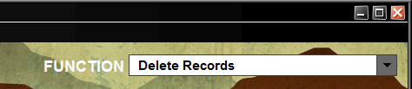

2. Click Scan/De .. (Scan/Delete).
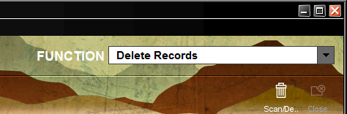

3. The Scan/Delete Items box will appear. Scan the barcode of the item.
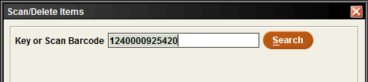

4. Click the Search button and the item information will appear under Barcode, Title and Call Num. The Delete box will be checked.
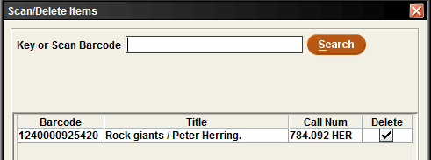

5. Continue scanning the barcodes for all the items that need to be deleted. Click Search after each individual barcode.
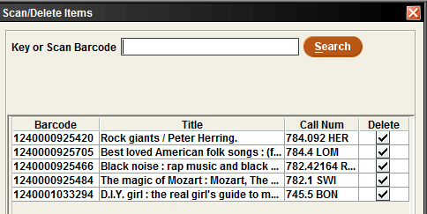

6. Once all the barcodes have been enterd, click the Delete Items button.
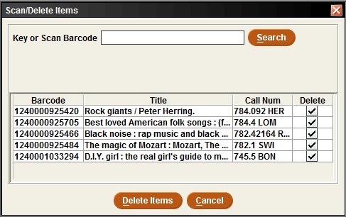

7. Once the Delete Items button is clicked, the following pop-up box will appear. Click Yes.
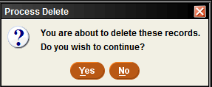

8. The Process Summer box will appear showing how many records were COMPLETELY deleted from your database. The Record Number is listed. In addition, an Errors tab will list any items that did not delete.
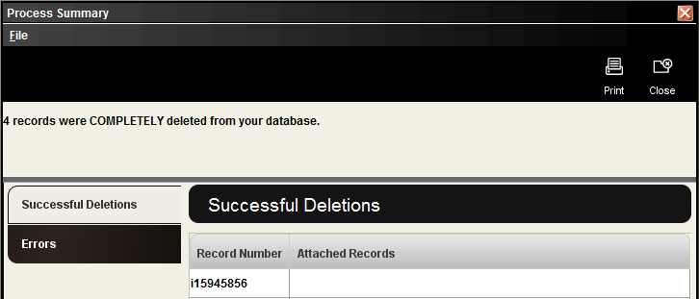

9. Clicking on the Errors tab will show a list of items that did not delete.
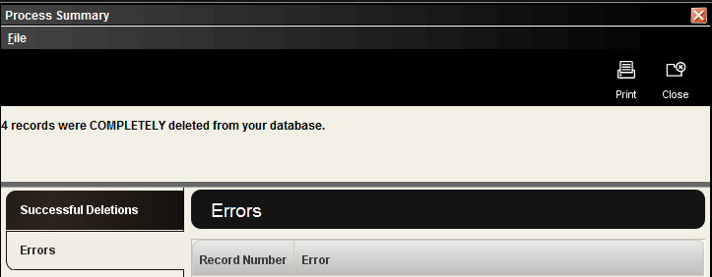

10. Optional – The list of Record Numbers that have just been deleted can be sent to an email address by clicking the Print button. If no list is needed, click Close.
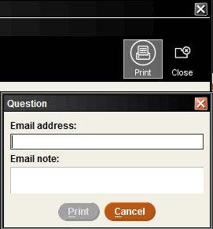

Using a Review File from Create Lists
1. Go to the Delete Records Function from the Sierra drop-down list.

2. The default screen will be Review file:
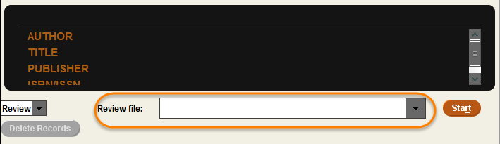

3. Find your Review file from the drop down menu and click Start.
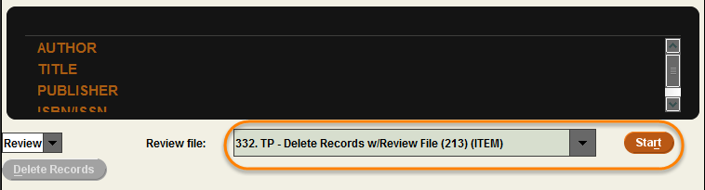

4. You will see two messages about deleting items records only, or item records and attached Bibliographic records. You will also see all the records and descriptions for all the items.
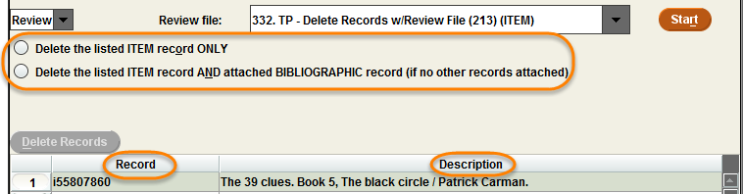

5. Choose the “Delete the listed ITEM record ONLY.” Click Delete Records.
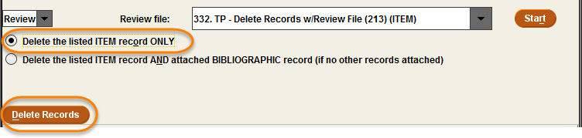

6. You will get a warning message that “Deleted Records Cannot Be Recovered,” and asks if you are “Absolutely Certain you want to delete these records?” Click Yes.
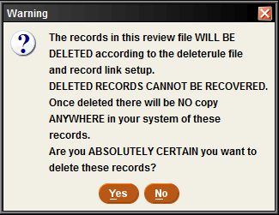

7. You will get Deleting records processing bar.
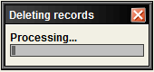

8. You will get a Process Summary. This will show how many files were completely deleted. You should check for any Errors. You will also get a list of Record Numbers.
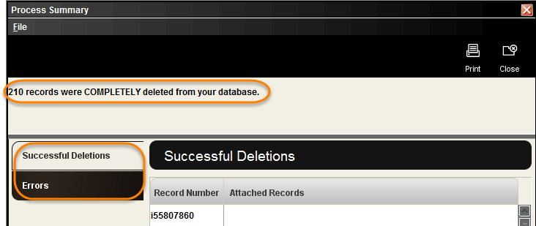

9. Here is an example of some of the Errors you may see when deleting items. You would transfer the hold, and check in the items. 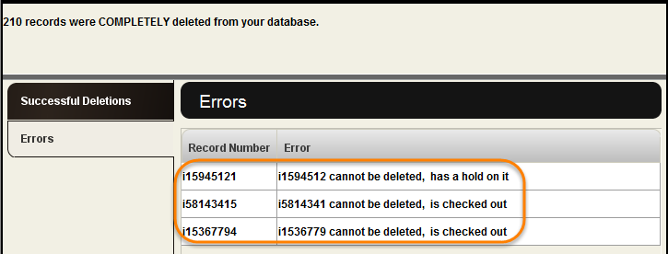

10. You can Print this information to a local printer or email printer.
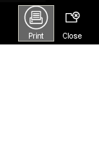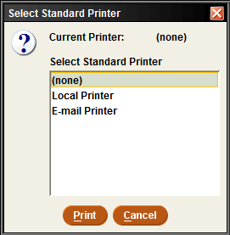

11. Undeleted items will also show in your review file. You could manually delete those items after the errors have been cleared, or use Delete Records Function with the review file again.
