Programing a barcode scanner to add barcodes to Create Lists
Scan each of these barcodes in sequence
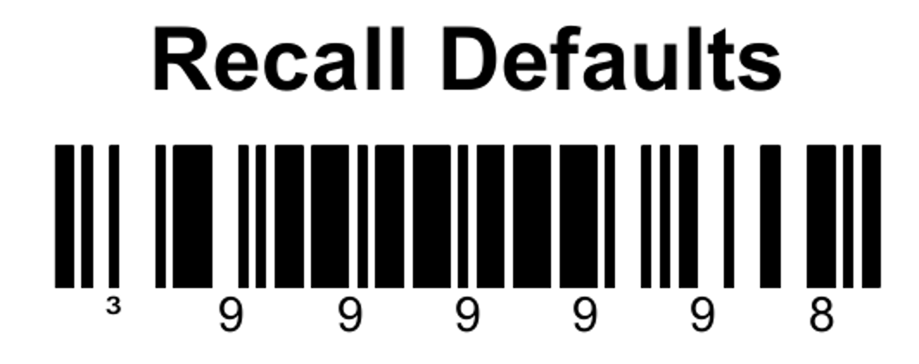
This will reset the scanner to factory default settings

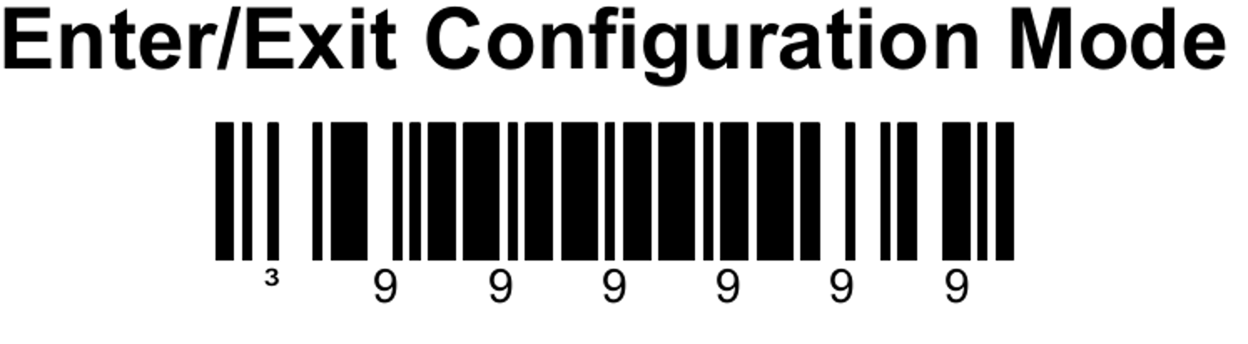

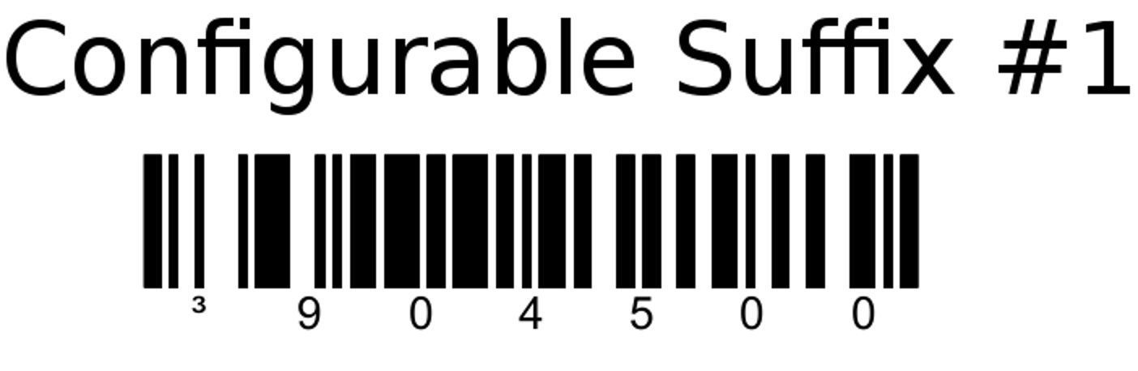

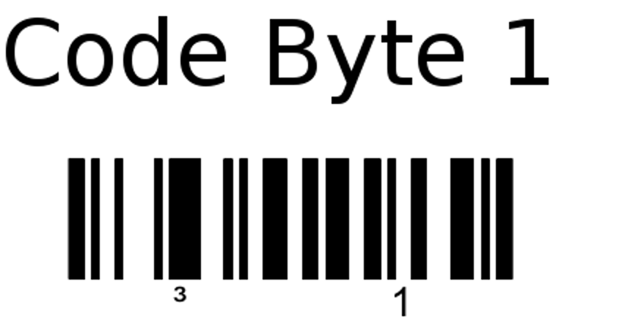

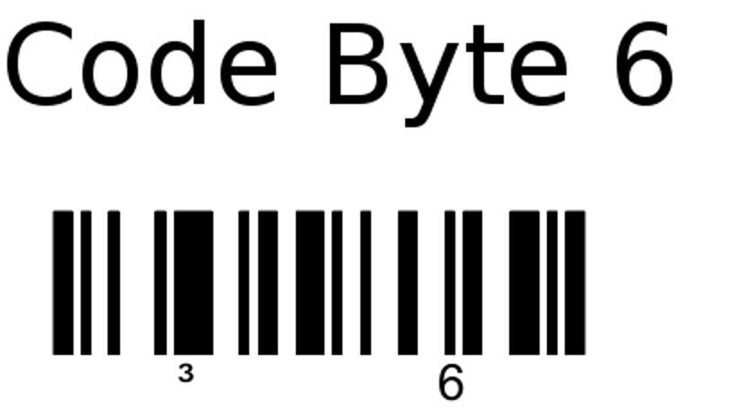

Sometimes the second 6 doesn’t work. It thinks you are scanning the same barcode a second time by mistake. Keep trying it. If it gets messed up, just start over with Recall Defaults (maybe Exit Configuration mode first)
